|  |  |
| --- | --- |
|  | School of Engineering |

|  |  |  |
| --- | --- | --- |
| **ELC 411-02** | **Embedded Systems** | **Fall 2019** |

**LAB REPORT**

**Design Assignment 4: Timers & Interrupts**



**Date: November 15th, 2019**

**Submitted by: Jordan Sinoway, Condor Gao**

**Instructor: Dr. Larry Pearlstein**

**PSoC Schematic:**

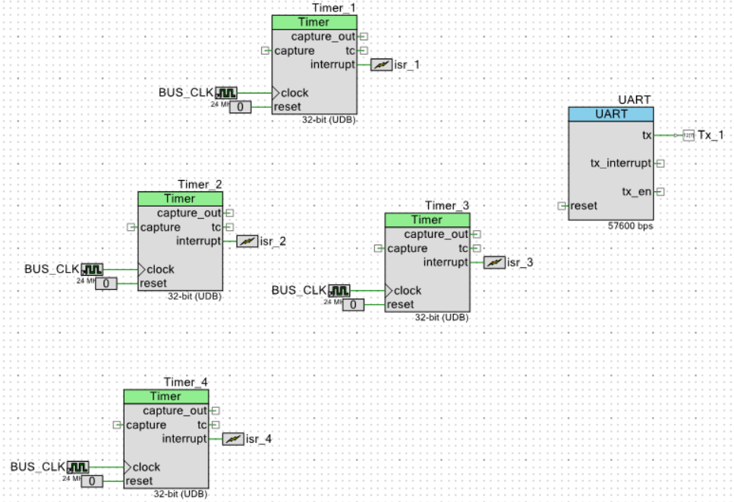

**Tera Term Window Based on Section 3:**

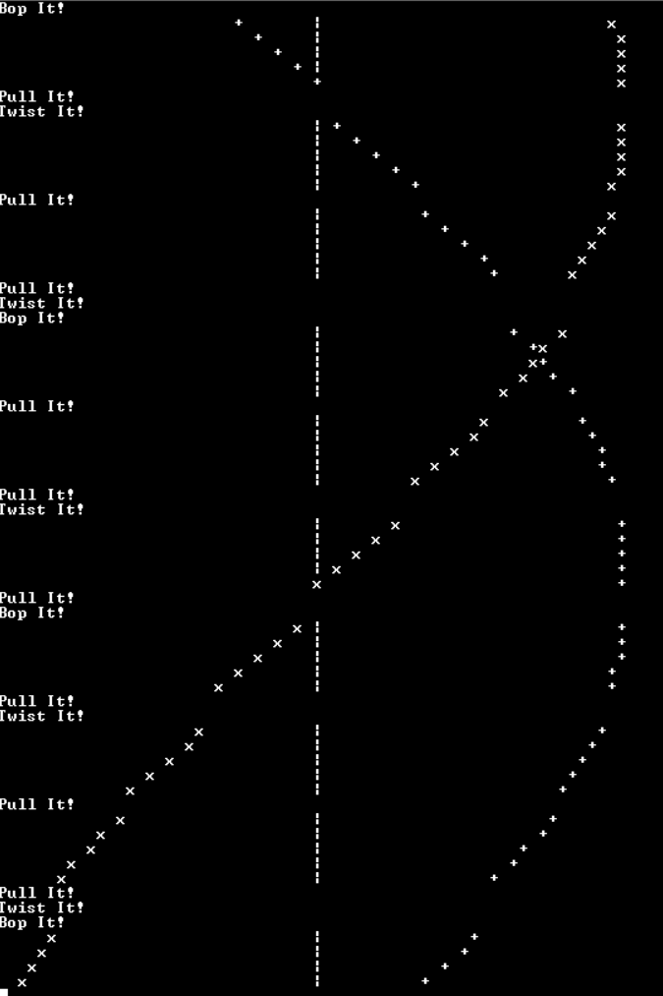

**Tera Term Window Post Section 5:**

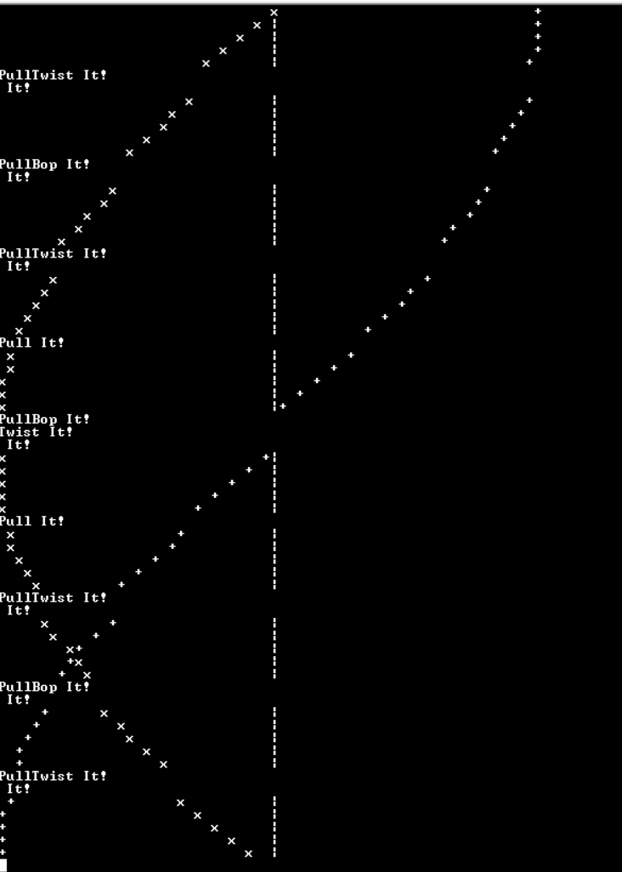

**Explanation:  
What are the default priorities on all four interrupts?**

Default:

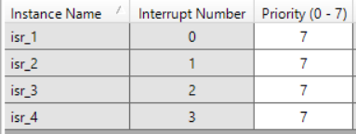

Modified:

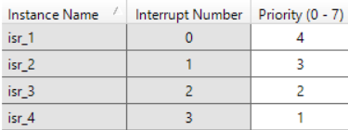

**Modify the interrupt priorities to match those shown below. Rerun. What do you see? Can you explain that? Can you draw a timing diagram that helps to explain the situation?**

As shown above in the 3rd figure, now that the interrupts have priorities have been assigned, the interrupts are interrupting each other, as well as the main program. Previously, all of the interrupts were assigned with the same priority, so they operated sequentially, as shown in the 2nd figure. Now, the interrupts can be interrupted by other interrupts, and will finish after the higher priority interrupts have run. For example, the 3rd figure shows “PullTwist It! It!”, which occurs because isr_3 (“Twist It!”) has a higher priority than isr_2 (“Pull It!”). A timing diagram, shown below, describes the behavior of the interrupts.

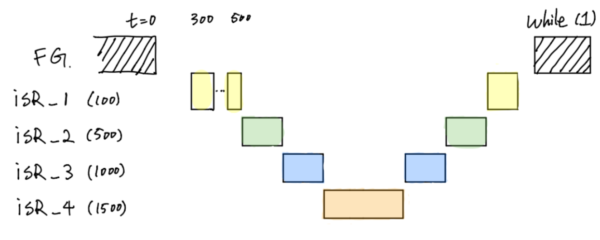

**Code:**

**ISR_1:**

CY_ISR(isr_1_Interrupt)

{

#ifdef isr_1_INTERRUPT_INTERRUPT_CALLBACK

isr_1_Interrupt_InterruptCallback();

#endif /* isr_1_INTERRUPT_INTERRUPT_CALLBACK */

/* Place your Interrupt code here. */

/* `#START isr_1_Interrupt` */

char msg_str[67];

int64_t rsq; // Holds square of real component

int64_t isq; // Holds square of imag component

int32_t sgn_real; // +/-1, based on x_real > 0 or < 0

int32_t sgn_imag; // +/-1, based on x_imag > 0 or < 0

x_real = x_real*COS_0 - x_imag*SIN_0; // QM.N * QM.N -> Q2M.2N

x_real = (x_real + FIXED_ONE_HALF) >> FIXED_N; // convert back to QM.N, with rounding

x_imag = x_real*SIN_0 +x_imag*COS_0; // QM.N * QM.N -> Q2M.2N

x_imag = (x_imag + FIXED_ONE_HALF) >> FIXED_N; // convert back to QM.N, with rounding

sgn_real = x_real >= 0 ? 1 : -1; // signum of x_real

sgn_imag = x_imag >= 0 ? 1 : -1; // signum of x_imag

rsq = SQR(x_real); // QM.N * QM.N -> Q2M.2N

rsq = (rsq + FIXED_ONE_HALF) >> FIXED_N; // convert back to QM.N, with rounding

isq = SQR(x_imag); // QM.N * QM.N -> Q2M.2N

isq = (isq + FIXED_ONE_HALF) >> FIXED_N; // convert back to QM.N, with rounding

// The goal is for 'x' to represent a value on the unit circle, i.e. complex magnitue

// should be unity. Because of quantization error (which will even occur with double

// precision, need some way of avoiding collapsing to zero, or growing to infinity

//

// My quick and dirty solution is to push both real and imaginary part down toward

// zero a smidgen if the magnitude is greater than one, and away from zero otherwise

if (rsq+isq > FIXED_ONE)

{

x_real -= sgn_real;

x_imag -= sgn_imag;

}

else

{

x_real += sgn_real;

x_imag += sgn_imag;

}

build_plot_str( msg_str, (int) x_real, (int) x_imag ); // Builds the string for output (at 57,600 baud, to serial port

UART_PutString(msg_str); // Sends string to serial port

Timer_1_ReadStatusRegister();

/* `#END` */

}

**ISR_2:**

CY_ISR(isr_2_Interrupt)

{

#ifdef isr_2_INTERRUPT_INTERRUPT_CALLBACK

isr_2_Interrupt_InterruptCallback();

#endif /* isr_2_INTERRUPT_INTERRUPT_CALLBACK */

/* Place your Interrupt code here. */

/* `#START isr_2_Interrupt` */

char msg[32];//message string

sprintf(msg, "Pull It!\r\n"); //printing formatted string

UART_PutString(msg); //sending formatted string to UART

Timer_2_ReadStatusRegister(); //check timer 2

/* `#END` */

}

**ISR_3:**

CY_ISR(isr_3_Interrupt)

{

#ifdef isr_3_INTERRUPT_INTERRUPT_CALLBACK

isr_3_Interrupt_InterruptCallback();

#endif /* isr_3_INTERRUPT_INTERRUPT_CALLBACK */

/* Place your Interrupt code here. */

/* `#START isr_3_Interrupt` */

char msg[32];

sprintf(msg, "Twist It!\r\n");//printing formatted string

UART_PutString(msg); //sending formatted string to UART

Timer_3_ReadStatusRegister();//check timer 3

/* `#END` */

}

**ISR_4:**

CY_ISR(isr_4_Interrupt)

{

#ifdef isr_4_INTERRUPT_INTERRUPT_CALLBACK

isr_4_Interrupt_InterruptCallback();

#endif /* isr_4_INTERRUPT_INTERRUPT_CALLBACK */

/* Place your Interrupt code here. */

/* `#START isr_4_Interrupt` */

char msg[32];

sprintf(msg, "Bop It!\r\n");//printing formatted string

UART_PutString(msg); //sending formatted string to UART

Timer_4_ReadStatusRegister();//check timer 4

/* `#END` */

}